**LAB ASSIGNMENT**

**Amit Kumar Sahu**

**18MIS7250**

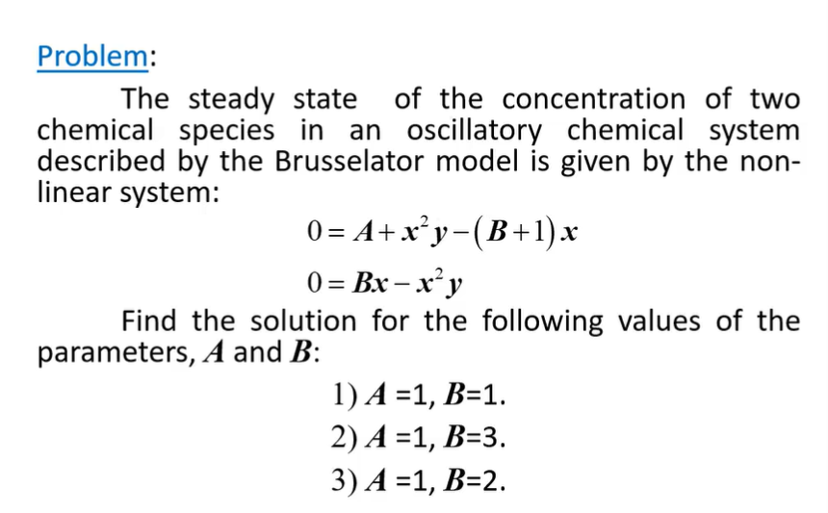

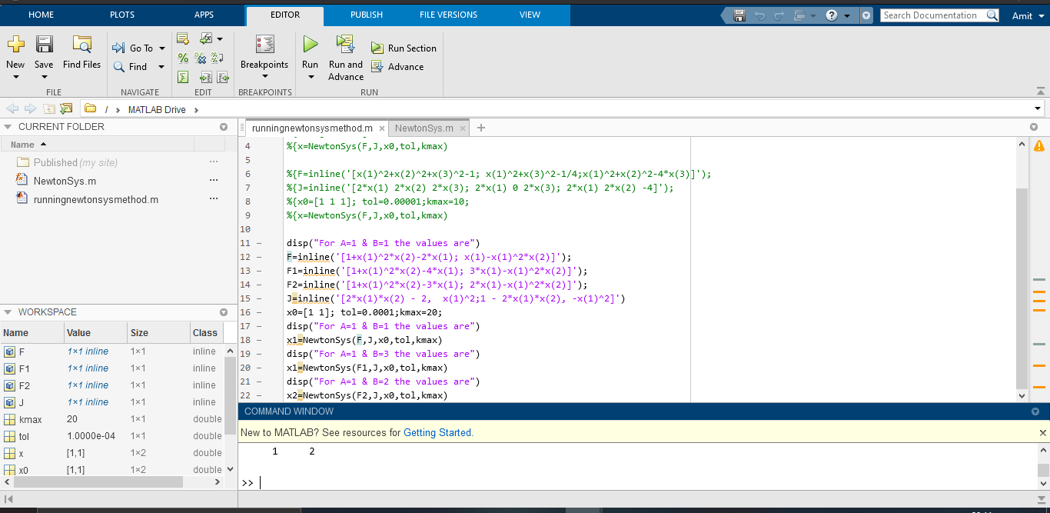

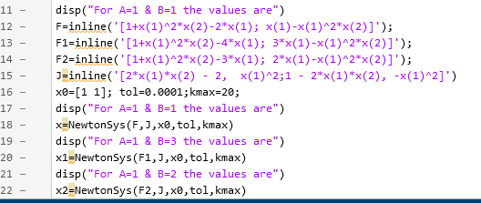

runningnewtonsysmethod

For A=1 & B=1 the values are  
  
J =  
  
 Inline function:  
 J(x) = [2*x(1)*x(2) - 2, x(1)^2;1 - 2*x(1)*x(2), -x(1)^2]  
  
For A=1 & B=1 the values are  
 1 1 1 0  
  
Newton method has converged  
  
x =  
  
 1 1  
  
For A=1 & B=3 the values are  
 1 1 3 2  
  
  
iter =  
  
 2  
  
 2 1 3 0  
  
Newton method has converged  
  
x1 =  
  
 1 3  
  
For A=1 & B=2 the values are  
 1 1 2 1  
  
  
iter =  
  
 2  
  
 2 1 2 0  
  
Newton method has converged  
  
x2 =  
  
 1 2